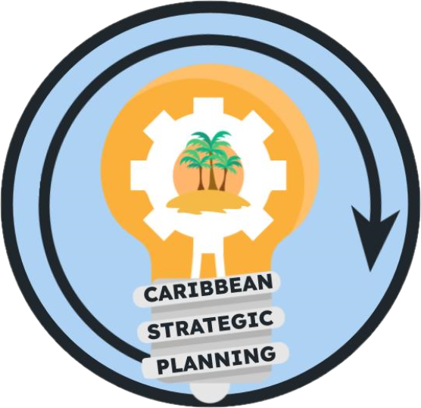Team Charter

Project: Define needs and mechanisms for establishing a funding governance structure

**Purpose**

Our purpose is to define needs and mechanisms for establishing a funding governance structure with the end goal of an informative, transparent funding framework to facilitate coordination of activities.

**Goals**

Our goals are to identify structures that are equitable for fishers, contractors, and agencies that facilitate the collection of data to inform fisheries management being sensitive to local differences across the U.S. Caribbean.

Immediately, to do that, we need to define the need and identify the mechanisms of funding in the Caribbean currently.

1. Need - define in series of statements
   1. Who
   2. What
   3. Why
   4. Where
2. Create conceptual model of current funding, collaborations, structures
   1. Who/What/Why/Where
   2. Transfers
   3. Pipelines
   4. Bottlenecks
3. Benchmark other regional funding mechanisms that address bottlenecks
4. Modify conceptual model to address gaps in funding, collaborations, structures

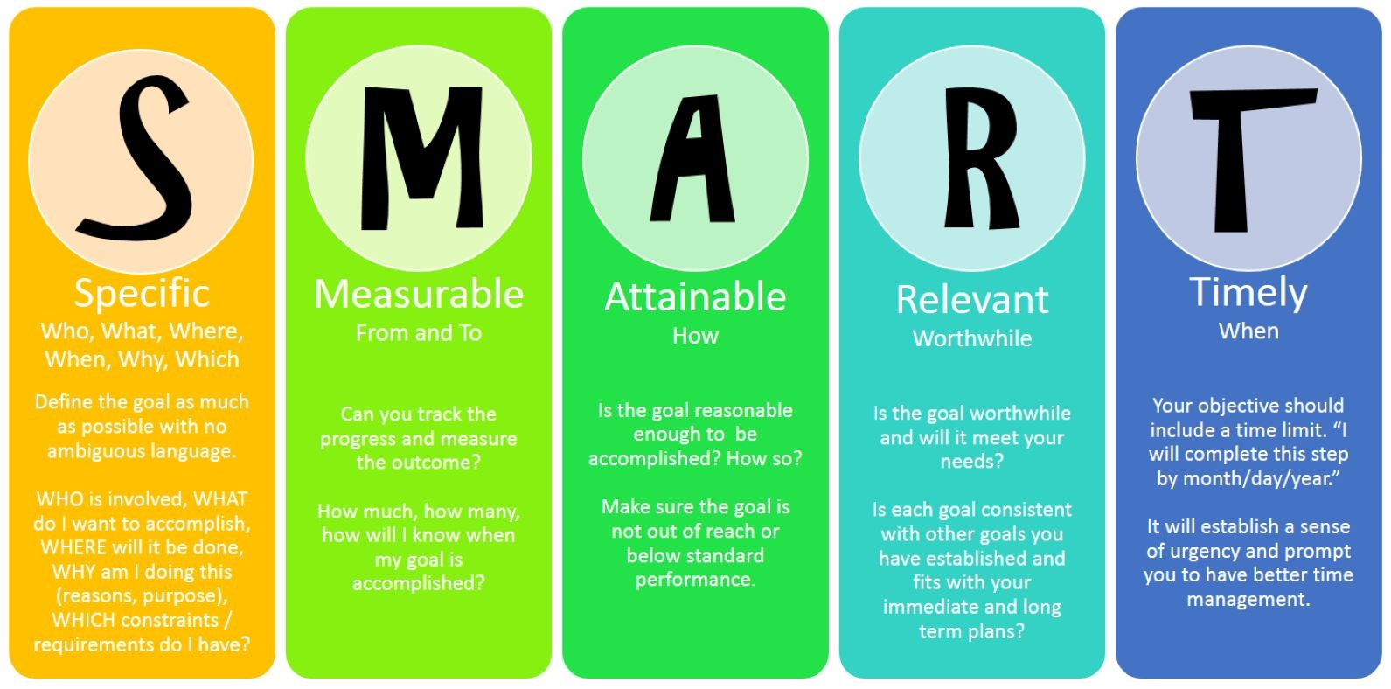

Our ideal outcome within the next five years is an equitable funding pipeline that promotes and coordinates across agencies, universities, programs, and individuals run by a governance structure.

The deliverables will be…

1. A document that details the current state of funding structures and bottlenecks
2. A conceptual model or flow diagram that describes the process of how money is transferred to the various agencies, universities, programs, and individuals
3. A proposed mechanism to streamline the process
4. A report out presentation to the strategic planning participants detailing our findings and deliverables
5. The establishment of a steering committee tasked with establishing the proposed funding governance structures in an existing, overarching governance structure, such as CFMC, SERO, or SEFSC

**Governance Team**

* *Lead*: Nicole Angeli
* *Members*: Kevin McCarthy, Mike Feeley, Sarah Stephenson, Steve Smith, Grisel Rodriguez, Joy Merino, Maureen Madera Garcia
* *Stakeholders*: CFMC, CIMAS, DNER/DRNA, DPNR, EBFM TAP, NOAA HQ, NPS, PRSG, QM/CI PSG, SEFSC, SERO, SSC, UPR, USC-A, UVI
* *KSAs*:
  + Who is missing from this list?

**Team Process**

* *Meeting day/time*: Friday 10:30-12:00 PM ET
* *Meeting frequency*: every 4 weeks
* *Decision-making procedures*: Consensus
* *Team communication*: Google Meet for standing or any ad-hoc meetings, group emails for routine communications between meetings, and comments in working drafts placed in the team google drive folder.

**Team Norms**

* *Values*:
  + Integrity, reproducibility, transparency, and communication of data
  + Innovation through adaptive management and continuous improvement
  + Respect and trust in data and partnerships
  + Diversity and inclusivity of data sources, data input, communities, and stakeholder ideas
  + Collaboration and cooperation in the collection and dissemination of data
* *Agreements*: The Team agrees to work in an environment of mutual respect where all Team Members will be given an opportunity and encouraged to present ideas and viewpoints. Hand raising will not be needed during google meets as long as team members do not talk over each other.

**Supporting Resources**

* *Google Drive folder*: [Working Groups](https://drive.google.com/drive/folders/1GR0WWtq_eOGT89s0n8p1imwZ1ntcnczN)
* *Project facilitation*: Rachel Banton (rachel.banton@noaa.gov)
* *Process facilitation*: Richard Maclin, Vivian Matter (vivian.matter@noaa.gov), Jenny Suter (jenny.suter@noaa.gov)

**Metrics**

Success will be measured by a document that details the current state and bottlenecks, the establishment of a steering committee (involving additional members), and a proposed mechanism to streamline the process

**References from Strategy Deployment X-Matrix:**

Top level priorities

1. Establish a team to define needs and mechanism for establishing a funding governance structure

Annual Breakthrough Objectives:

1. Define the Needs and mechanisms to streamline the process for establishing a funding governance structure

3-5 year breakthrough

1. Establish funding governance structures that are equitable for fishers, contractors, agencies, and island and allow for the collection of necessary data gaps to inform fisheries management

Performance Metrics

1. A document that details the current state and bottlenecks
2. The establishment of a steering committee (involving additional members)
3. A proposed mechanism to streamline the process